In-depth Analysis of X.509 Digital Certificates using a Real-world Website
Submitted by: Gowtham S Register Number: 814723104043
Department: Computer Science Engineering
College: SRM TRP Engineering College

Abstract
In the modern digital landscape, the security of data in transit is paramount. As millions of transactions and sensitive communications occur over the Internet every second, the necessity for a robust authentication and encryption framework is critical. This project explores the SSL/TLS (Secure Sockets Layer/Transport Layer Security) protocol, which serves as the backbone of secure communication. Central to this protocol is the X.509 digital certificate—a standard defining the format of public key certificates.
Digital certificates act as electronic "passports" that verify the identity of a website or server. They ensure that a user is communicating with the intended recipient and not an imposter, thereby preventing widespread cyber threats such as Man-in-the-Middle (MITM) attacks. This abstract outlines the fundamental role of Certificate Authorities (CAs) in establishing a "Chain of Trust." By analyzing a live certificate from *.google.com, this project provides a practical look at cryptographic fields, validity periods, and fingerprinting techniques. The study concludes that the rigorous implementation of X.509 standards is indispensable for maintaining the integrity, confidentiality, and availability of information in an increasingly connected world.

Table of Contents
- Chapter 1: Introduction ......................................................................................3
- Chapter 2: X.509 Certificate Overview ......................................................................................5
- Chapter 3: Certificate Authorities (CA) ......................................................................................7
- Chapter 4: Practical Experiment ......................................................................................9
- Chapter 5: Certificate Analysis (Main Part) ......................................................................................11
- Chapter 6: Cryptography Behind Certificates ..................................................................................... 14
- Chapter 7: Security Analysis ......................................................................................16
- Chapter 8: Applications of Digital Certificates ......................................................................................18
- Chapter 9: Advantages and Limitations ......................................................................................20
- Chapter 10: Conclusion ......................................................................................22
- References ..................................................................................... 24

1: Introduction

1.1 Overview of Network Security
Network security consists of the policies, processes, and practices adopted to prevent, detect, and monitor unauthorized access, misuse, modification, or denial of a computer network. In the context of the Internet, it primarily focuses on securing the communication channel between a client (browser) and a server.

1.2 Importance of Secure Communication
Without secure communication, sensitive data—such as credit card numbers, login credentials, aChapternd personal identity information—is transmitted as plain text. This makes it susceptible to "eavesdropping," where an unauthorized third party intercepts and reads the data.

1.3 Introduction to SSL/TLS Protocol
The Transport Layer Security (TLS) protocol, and its predecessor SSL, provide the encryption layer for HTTP, turning it into HTTPS. It uses a combination of symmetric and asymmetric cryptography to ensure that data remains private and integral during transit.

1.4 Need for Digital Certificates
Encryption alone is insufficient if you do not know who you are encrypting data for. Digital certificates provide the "Authentication" component. They verify that the public key you are using to encrypt data actually belongs to the domain you are visiting.

Chapter 2: X.509 Certificate Overview

2.1 Definition of X.509 Standard
X.509 is an ITU-T standard for a public key infrastructure (PKI) and Privilege Management Infrastructure (PMI). It specifies standard formats for public key certificates, certificate revocation lists, and attribute certificates.

2.2 Structure of X.509 Certificate
An X.509 certificate is a data block that binds a public key to a specific identity (Subject). It is encoded using ASN.1 (Abstract Syntax Notation One) and typically follows a strict set of fields.

2.3 Components and Fields Explanation
- Version: Identifies which version of the X.509 standard applies.
- Serial Number: A unique positive integer assigned by the CA.
- Signature Algorithm: The algorithm used to sign the certificate.
- Issuer: The entity that verified the information and issued the certificate.
- Validity: The time interval during which the CA warrants that it will maintain information about the status of the certificate.
- Subject: The entity identified by the certificate.
- Public Key: The public cryptographic key of the subject.

2.4 Versioning (V1, V2, V3)
- V1 (1988): The initial version.
- V2 (1993): Added unique identifiers for subjects and issuers to prevent reuse.
- V3 (1996): Introduced Extensions, allowing for more flexibility, such as Subject Alternative Names (SAN) and Key Usage constraints.

Chapter 3: Certificate Authorities (CA)

3.1 Role of Certificate Authorities
A Certificate Authority (CA) is a trusted third-party entity that issues digital certificates. The CA acts as a guarantor of the website's identity. If a browser trusts the CA, it by extension trusts the certificates signed by that CA.

3.2 Trusted Root Authorities
Root CAs are at the top of the trust hierarchy. Their certificates are "self-signed" and are pre-installed in major operating systems and browsers.

3.3 Intermediate Certificates
To protect the Root CA, CAs rarely issue certificates directly from the root. Instead, they use "Intermediate CAs." If an intermediate key is compromised, the Root remains safe, and only the intermediate branch needs to be revoked.

3.4 Chain of Trust Concept
The Chain of Trust is a series of certificates that link the website's certificate back to a trusted Root CA.
- End Entity: *.google.com
- Intermediate: WR2
- Root: Google Trust Services Root

Chapter 4: Practical Experiment

4.1 Objective of the Experiment
The objective is to manually inspect the X.509 certificate of a high-traffic production website (google.com) to understand real-world implementation of PKI fields.

4.2 Tools Used
- Google Chrome Browser: Version 124+ (Certificate Viewer).
- Operating System: Windows/Linux.

4.3 Steps to View Certificate
- Open the Chrome browser and navigate to https://www.google.com.
- Locate the Lock Icon in the address bar.
- Select Connection is Secure > Certificate is Valid.
- Navigate through the "General," "Details," and "Certification Path" tabs to extract technical strings.

4.4 Screenshot Description
The viewer displays a window titled "Certificate Viewer: *.google.com." Under the "Details" tab, we see a hierarchical list of fields. The "Subject" field confirms the domain identity, while the "Issuer" field points to "WR2." The fingerprint section at the bottom displays a long hexadecimal string used for verification.

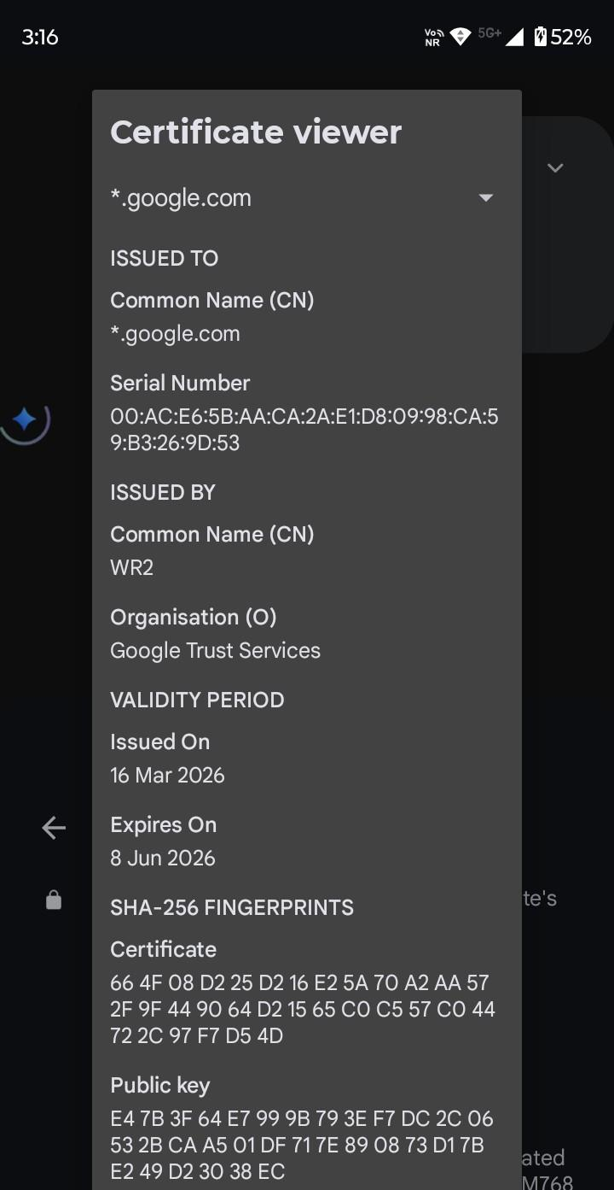

Screenshot Copy

Chapter 5: Certificate Analysis (Real-world Data)

5.1 Subject Information
- Common Name (CN): *.google.com
- Significance: The asterisk denotes a "Wildcard" certificate. This single certificate is valid for all subdomains under google.com, such as mail.google.com and drive.google.com.

5.2 Issuer Details
- Common Name (CN): WR2
- Organization: Google Trust Services
- Significance: This identifies the specific signing authority. Google acts as its own CA (Google Trust Services), providing them with greater control over their infrastructure security.

5.3 Temporal Validity
- Issued On: 16 March 2026
- Expires On: 8 June 2026
- Significance: The duration is approximately 84 days. This represents the modern industry shift toward short-lived certificates (90 days or less). Short lifespans minimize the window for an attacker to use a compromised key and force the use of automation (ACME protocol).

5.4 Serial Number
- Value: 00:AC:E6:5B:AA:CA:2A:E1:D8:09:98:CA:59:B3:26:9D:53
- Significance: This is the unique identifier for the certificate. If Google needs to revoke this certificate, this serial number is added to a Certificate Revocation List (CRL).

5.5 Public Key Details
- SHA-256 Key: E4 7B 3F 64 E7 99 9B 79 3E F7 DC 2C 06 53 2B CA A5 01 DF 71 7E 89 08 73 D1 7B E2 49 D2 30 38 EC
- Significance: This is the public key that clients use to encrypt the initial "pre-master secret" during the TLS handshake.

5.6 Certificate Fingerprint
- SHA-256: 66 4F 08 D2 25 D2 16 E2 5A 70 A2 AA 57 2F 9F 44 90 64 D2 15 65 C0 C5 57 C0 44 72 2C 97 F7 D5 4D
- Significance: A fingerprint is a hash of the entire certificate.

Chapter 6: Cryptography Behind Certificates

6.1 Public Key Cryptography
Also known as asymmetric cryptography, it uses two keys: a Public Key (distributed to everyone) and a Private Key (kept secret by the owner). Data encrypted with the public key can only be decrypted by the private key.

6.2 RSA vs. ECC Basics
While RSA was the standard for years, many modern certificates (like Google's) use Elliptic Curve Cryptography (ECC). ECC provides the same level of security as RSA but with much smaller key sizes, leading to faster handshakes and lower CPU usage.

6.3 Hashing and SHA-256
Hashing is a one-way function that turns data into a fixed-length string. SHA-256 (Secure Hash Algorithm 256-bit) is the current standard for digital signatures because it is resistant to collision attacks.

6.4 Digital Signatures
A digital signature is created by hashing the certificate data and then encrypting that hash with the CA's private key. The browser decrypts it with the CA's public key to verify authenticity.

Chapter 7: Security Analysis

7.1 Preventing Attacks
Certificates provide Authentication (knowing who you are talking to), Confidentiality (encryption), and Integrity (knowing data wasn't changed).

7.2 Man-in-the-Middle (MITM) Attacks
In an MITM attack, an attacker intercepts the communication. Without a certificate, the attacker could present their own public key. However, because the attacker cannot produce a certificate signed by a trusted CA for google.com, the browser will show a "Your connection is not private" warning.

7.3 Certificate Validation Process
- Check Dates: Is today's date within the Validity period?
- Check Revocation: Has the serial number been revoked via CRL or OCSP?
- Check Signature: Does the CA signature match the data?
- Check Chain: Does the issuer lead back to a trusted Root CA?

Chapter 8: Applications of Digital Certificates

8.1 HTTPS Websites
The most common use of X.509 is securing web traffic. HTTPS is now a requirement for SEO and user trust.

8.2 Online Banking
Banking applications use Extended Validation (EV) or high-assurance certificates to protect financial transactions.

8.3 Email Security (S/MIME)
X.509 certificates are used to sign and encrypt emails, ensuring that the sender's identity is verified and the content remains private.

8.4 Software Signing
Developers sign their applications with certificates. When a user downloads the software, the OS checks the signature to ensure the code hasn't been modified by malware.

Chapter 9: Advantages and Limitations

9.1 Advantages
- Standardization: Works across all devices and platforms globally.
- Scalability: Allows for millions of secure connections without a central "key directory."
- Trust: Leverages the existing ecosystem of trusted CAs.

9.2 Challenges and Vulnerabilities
- CA Compromise: If a CA is hacked, they can issue "fake" certificates for any site (e.g., the DigiNotar incident).
- Private Key Theft: If a server's private key is stolen, the certificate is useless until revoked.
- Quantum Computing: Future quantum computers could potential.

Chapter 10: Conclusion
This project has detailed the intricate workings of the X.509 standard through the lens of a real-world analysis of *.google.com. We have observed that digital certificates are more than just files; they are the fundamental units of trust in the digital age. By utilizing short-lived validity periods, robust hashing (SHA-256), and hierarchical chains of trust, the SSL/TLS ecosystem successfully secures billions of users. As cyber threats evolve, the transition toward automated certificate management and quantum-resistant algorithms will be the next frontier in network security.

References
- RFC 5280: "Internet X.509 Public Key Infrastructure Certificate and Certificate Revocation List (CRL) Profile."
- Stallings, W. (2020). Network Security Essentials: Applications and Standards. Pearson Education.
- Kaufman, C., Perlman, R., & Speciner, M. Network Security: Private Communication in a Public World. Prentice Hall.
- Google Trust Services. Certification Practice Statement (CPS). [pki.goog]
- Mozilla Wiki. CA/Certificate List.
- DigiCert Blog. The Evolution of X.509 Certificates.

